Guerrero, Gabriel Angelo F. Data Wrangling Using Pandas

2ECE-D 12/03/19

**DATA WRANGLING USING PANDAS: SCREENSHOTS**

PROBLEM 1

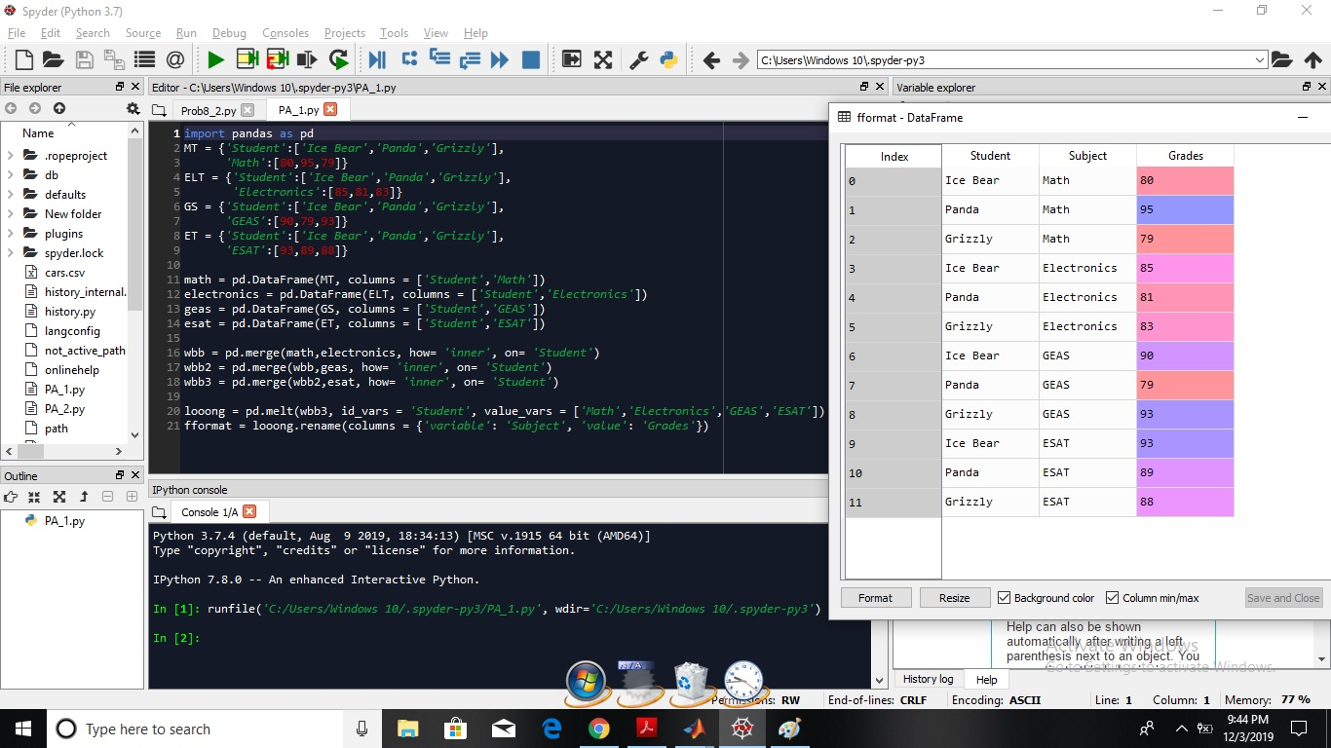

PROBLEM 2

